

Group Number: F33-DG06

**Sport Facility**

**Booking Platform**

Summary:

A sports facility platform that a user can use to book a facility such as a badminton, tennis and basketball court with a rate that will be based on the user’s status of membership.

|  |  |  |
| --- | --- | --- |
| Name | Matriculation Number | Course Code |
| Alfred Datui | U1520119E | EE4717 |
| Lee Qi Jian | U1520869J | EE4717 |

1. Table of Contents

1. Table of Contents 2

2. Table of Figures 5

3. Application Requirements and Specifications 7

4. Functional Requirements and Specifications 8

5. Design of the web application 9

5.1. Site Map 9

5.2. Story Board 9

5.2.1. Registration as a user (sign-up) 9

5.2.2. Log in as a user 10

5.2.3. Check a user’s booking (after login) 10

5.2.4. Apply for membership (after login) 10

5.2.5. Book a facility (after login) 11

5.3. Wireframe 11

5.3.1. Homepage 11

5.3.2. Sign up 12

5.3.3. Profile 12

5.3.4. My Booking 13

5.3.5. Facility Booking 13

5.3.6. Timetable 14

5.3.7. Membership 14

5.4. Database 15

5.4.1. letssport table 15

5.4.2. facility table 15

5.4.3. booking table 15

5.5. Web application testing plan 16

6. Implementation 18

6.1. Coding of the web pages 18

6.1.1. Home(Login) 18

6.1.2. Sign-up 18

6.1.3. My Account 18

6.1.4. My Booking 18

6.1.5. Facility Booking 18

6.1.6. Membership 18

6.1.7. Timetable 18

7. Testing of web application 19

7.1. Home page 19

7.1.1. Login form 20

7.2. Sign Up page 20

7.3. Home page (After Login) 21

7.4. My Account page 22

7.5. My Booking page (No results) 22

7.6. Booking facility page 23

7.6.1. Booking facility available timeslot 25

7.6.2. Booking limit exceed 25

7.7. My Booking page (Records exist) 26

7.8. Membership page 26

8. Conclusion 27

9. Appendices: 28

9.1. Source Codes 28

9.1.1. index.php 29

9.1.2. signup.php 31

9.1.3. myAcount.php 33

9.1.4. mybooking.php 34

9.1.5. facilityBooking.php 35

9.1.6. timetable.php 36

9.1.7. membership.php 38

9.1.8. login_user.php 39

9.1.9. logout.php 39

9.1.10. book_facility.php 40

9.1.11. header.php 41

9.1.12. hero.php 42

9.1.13. footer.php 43

9.1.14. bemember.php 43

9.1.15. sidebar.php 44

9.1.16. Add_New_User.php 45

9.1.17. dbconnect.php 45

10. index.css 46

1. Table of Figures

Figure 1:Site Map 12

Figure 2: Registration as a user (sign-up) 12

Figure 3: Log in as a user 13

Figure 4: Check a user’s booking (after login) 13

Figure 5: Apply for membership (after login) 13

Figure 6: Book a facility (after login) 14

Figure 7: Homepage 14

Figure 8: Sign up 15

Figure 9: Profile 15

Figure 10: My Booking 16

Figure 11: Facility Booking 16

Figure 12: Timetable 17

Figure 13: Membership 17

Figure 14: letssport table 18

Figure 15: facility table 18

Figure 16: booking table 18

Figure 17: Home page 22

Figure 18: Header 22

Figure 19: Login form 23

Figure 20: Sign Up 23

Figure 21: Sign Up completed 24

Figure 22: Homepage (After Login) 24

Figure 23: Header (After Login) 24

Figure 24: My Account 25

Figure 25: My Booking – No Results 25

Figure 26: Booking facility 26

Figure 27: Booking facility type 26

Figure 28: Booking facility date 26

Figure 29: Booking facility timeslot 1 27

Figure 30: Booking facility testing 27

Figure 31: Booking confirmed 27

Figure 32: Booking facility timeslot 2 28

Figure 33: Booking Facility timeslot 3 28

Figure 34: Booking limit exceed 28

Figure 35: My Booking (Records exist) 29

Figure 36: Membership for non-members 29

Figure 37: Membership 29

1. Application Requirements and Specifications

R1. This application is a sports facility online booking. As a user, you can book facilities online.

R2. We have 2 kinds of users (non-member and member).

R3. Each user is allowed to book maximum 2 hours per day for each facility and a user only can book a facility at least one day from on the day where user books.

R4. Members are allowed to have access to gym and swimming pools and book facilities.

R5. There are 2 types of rates:

* Non-member rate
* Member rate

R6. Upon successful booking, the users will receive the booking details by email.

1. Functional Requirements and Specifications

R1. This application is a sports facility online booking. As a user, you can book facilities online.

* Upon registration as a user, by default, a user will be a non-member user.
* There will be a side bar navigation at the user’s dashboard to register as a member.

R3. Each user is allowed to book maximum 2 hours per day for each facility and a user only can book a facility at least one day from on the day where user books.

* When a user books a facility, a user will be checked whether the user has booked the facility for more than 2 hours.
* An alert will be shown whether the booking is successful or unsuccessful.
* There is a validation for the date input (only can book at least one day from on the day where the user book.

R5. Rates

* A table of different rates for all facilities will be shown on the “Rate” page.
* After the user chooses the facility on “Facility Booking” page, a timetable will be shown for the selected facility. (The timetable will only show the available timing).

R6. Upon successful booking, the users will receive the booking details by email.

* Upon successful booking, an email will be issued to the registered email of the user.

1. Design of the web application
   1. Site Map

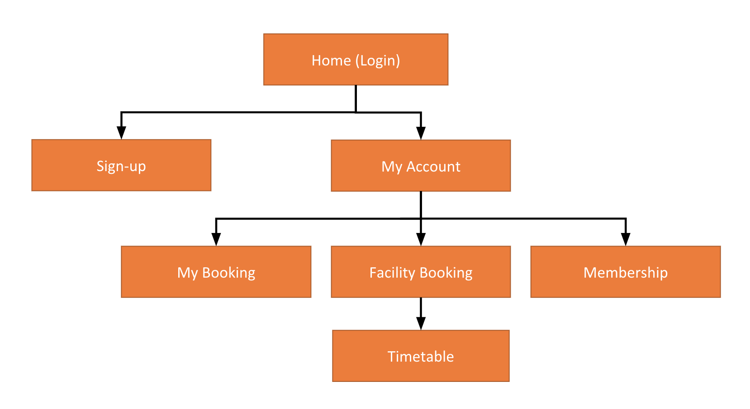

Figure :Site Map

* 1. Story Board
     1. Registration as a user (sign-up)

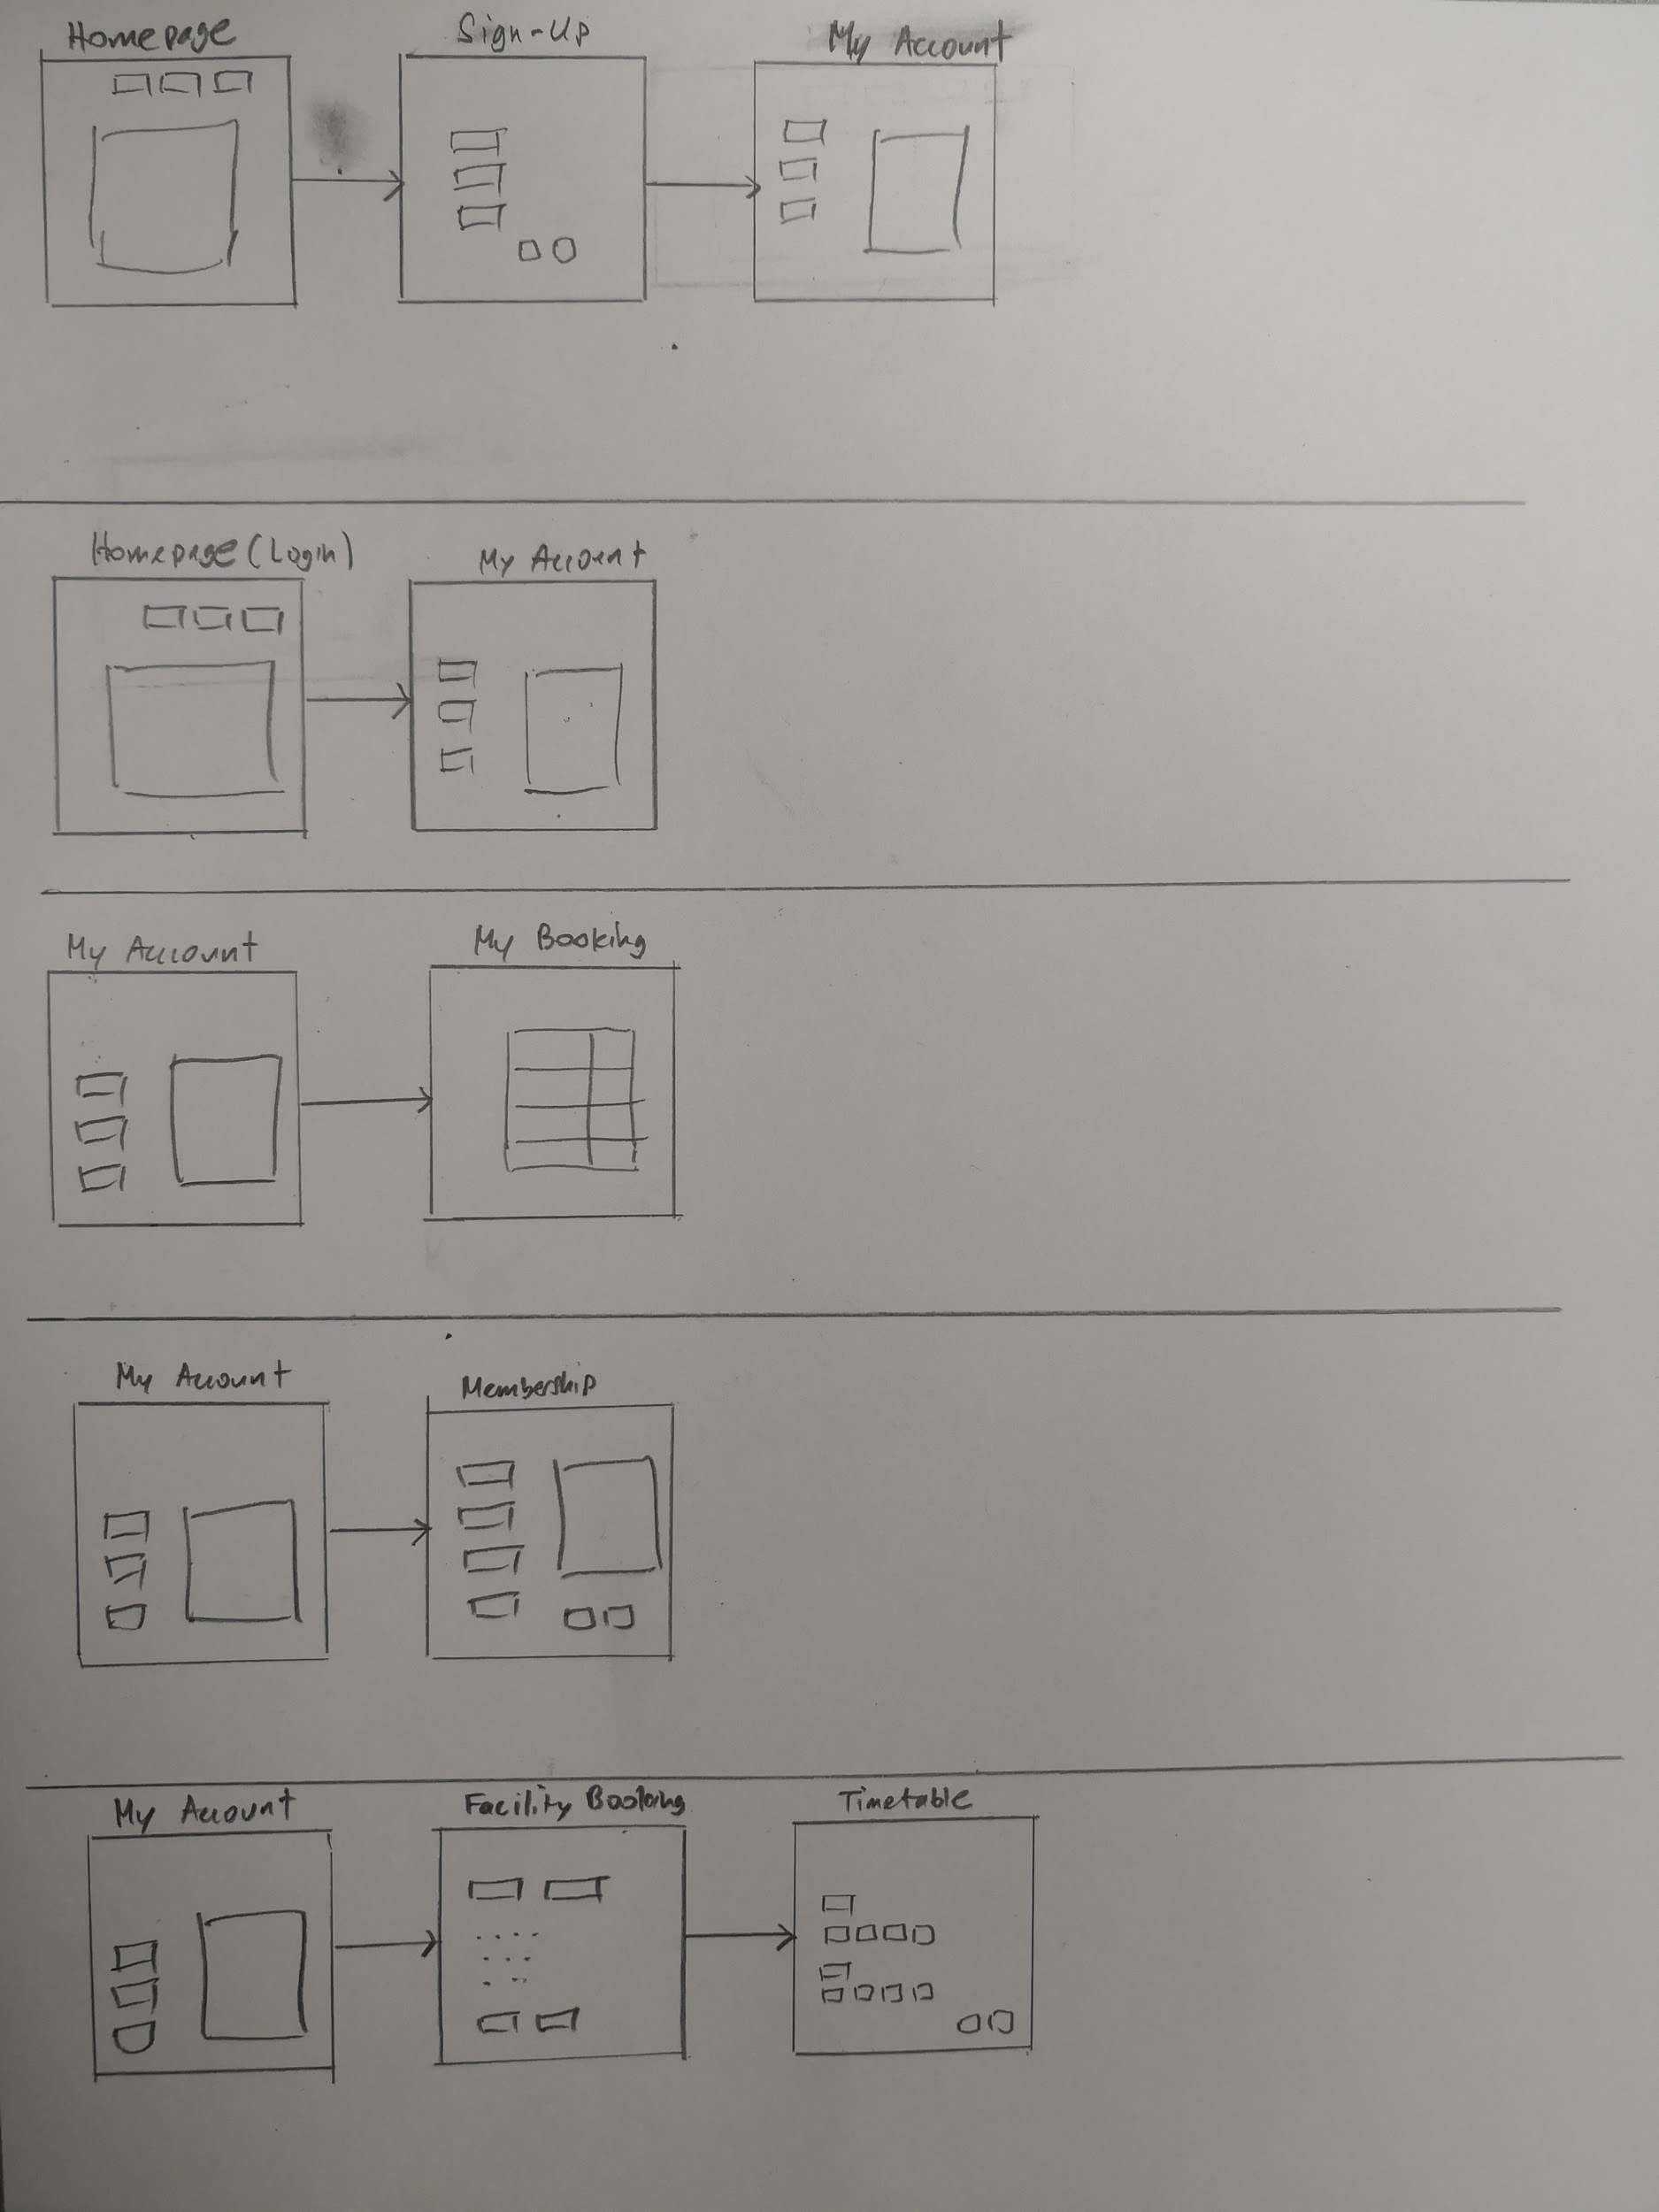

Figure : Registration as a user (sign-up)

Firstly, before users book a facility, they need to register to the website. By clicking the login navigation bar on the homepage. After clicking, there will a pop-up window appear for users to log in. Users can find the sign-up button to go to the sign-up page. In the sign-up page, users are to fill in their particular details and then register as new user. After the registration, users will be directed to the “My Account” page.

* + 1. Log in as a user



Figure : Log in as a user

To login, user needs to press login navigation bar and a pop-up window will appear. A user needs to fill his username and password to login.

* + 1. Check a user’s booking (after login)



Figure : Check a user’s booking (after login)

A user can view his booking by clicking the “My Booking” navigation bar from “My Account” page and he will be directed to the “My Booking” page. In the booking page, the existing booking details will be shown in a table.

* + 1. Apply for membership (after login)



Figure : Apply for membership (after login)

A user can apply for membership in order to access some facilities in the sport center (gym and swimming pool). In addition, he is able to enjoy cheaper rates for all facilities. Applying for membership is a subscription basis that user needs to pay $10.00 every month. To apply for membership, a user need to click membership sidebar and the user will be directed to the membership page.

* + 1. Book a facility (after login)



Figure : Book a facility (after login)

In order for a user to book a facility, from “My Account” page, user needs to click the “My Booking” on sidebar and the user will be directed to the facility booking. In the facility booking, the user needs to specify what facility that the user wants to book with the available date (user can book a facility one week in advance). After filling the form, the user can press search button and will be directed to the timetable. In the “Timetable” page, the user needs to choose the time slots that the user wants to book and then press “Submit” button. Upon pressing the submit button, we will assume the 3rd party API will execute and then handle the payment process.

* 1. Wireframe
     1. Homepage

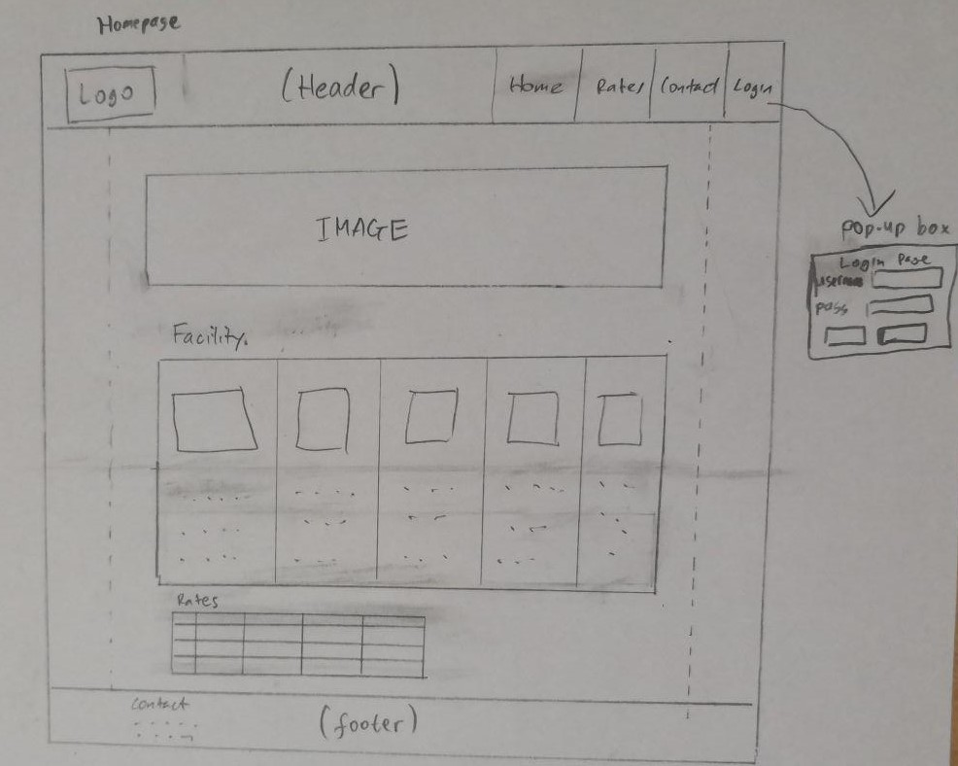

Figure : Homepage

* + 1. Sign up

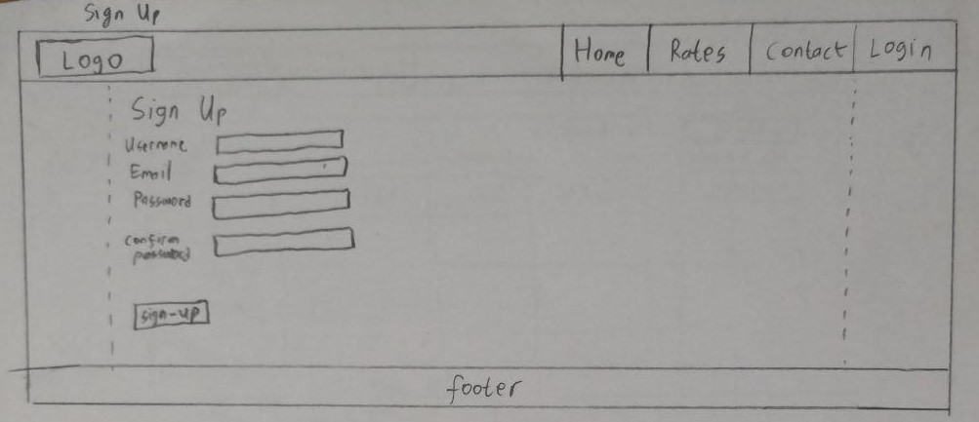

Figure : Sign up

* + 1. Profile

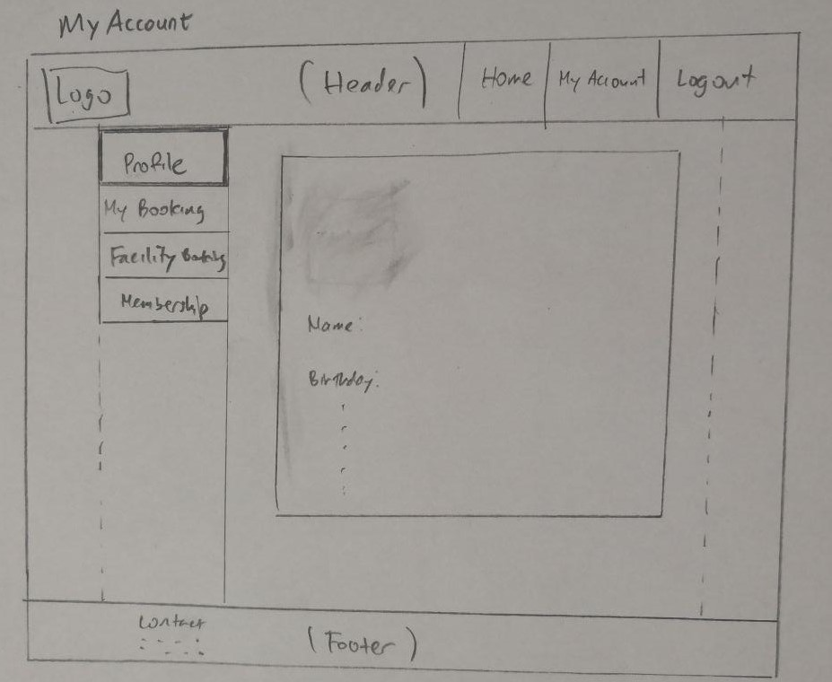

Figure : Profile

* + 1. My Booking

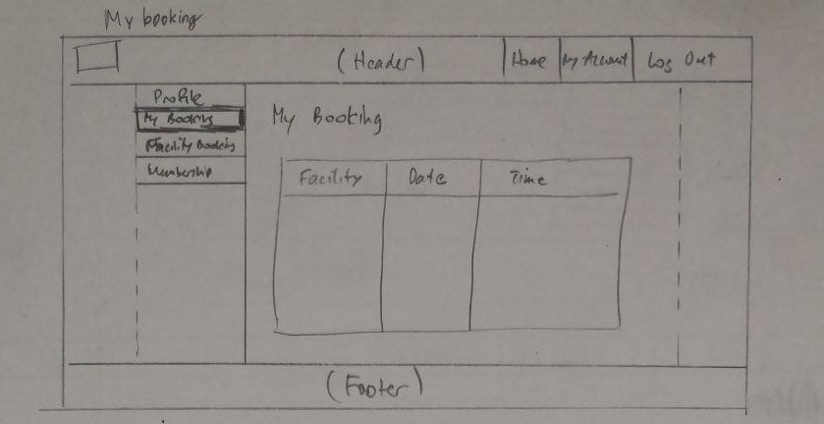

Figure : My Booking

* + 1. Facility Booking

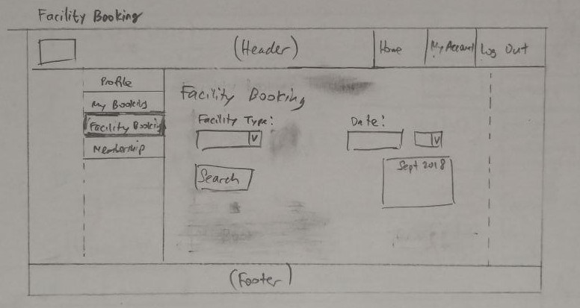Figure : Facility Booking

* + 1. Timetable

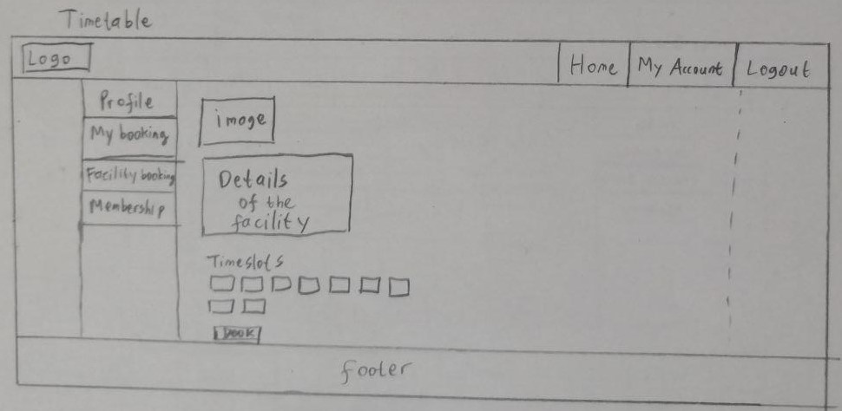

Figure : Timetable

* + 1. Membership

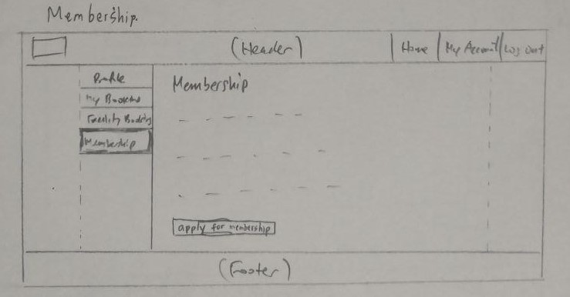

Figure : Membership

* 1. Database
     1. letssport table

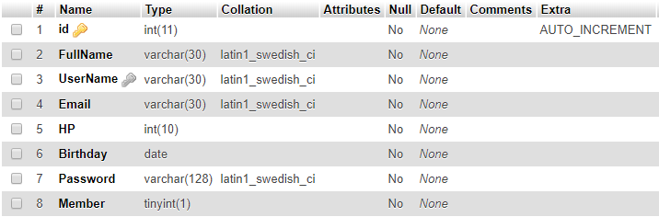

Figure : letssport table

This table is used for login and sign up sessions. Id is the primary key which will be used for session and to refer to other table (booking). Member column contains values ‘0’ which means the user is not member and ‘1’ which means the user is member.

* + 1. facility table

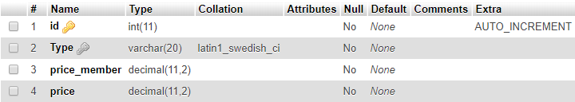

Figure : facility table

Facility table consist of the available facilities in Lets Sport with the price detail.

### booking table

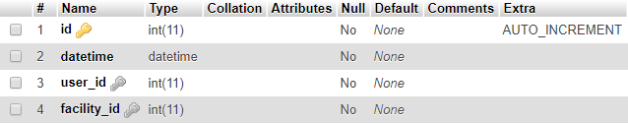

Figure : booking table

Users are able to make booking and then store in this table with the timing details. The users are able to see booking details from this table as well.

* 1. Web application testing plan

|  |  |  |
| --- | --- | --- |
| **Pages** | **Test** | **Pass/Fail** |
| Homepage | Login form pops up when the login navigation pressed | Pass |
| “Rates” scrolls to rates section when the rates navigation pressed | Pass |
| “Contact” scrolls to contact section when the contact navigation pressed | Pass |
| Registering to the website by going to signup page and submit the details | Pass |
| “Reset” button works in the sign up page to clear all the inputs | Pass |
| “Cancel” button works in the sign up page to go back to the homepage | Pass |
| “Contact No:” must have 8 digits | Pass |
| The text in “Password” an “Confirm Password” is checked if matched | Pass |
| The email input must contain ‘@’ and word after ‘@’. | Pass |
| Logging in as a user by filling the login inputs (username and password) | Pass |
| New record is inserted into letssport table in database | Pass |
| Duplicated record is restricted | Pass |
| Homepage (Login) | “Rates” and “Contact” disappears when the user already logged in | Pass |
| My Account appears when the user already logged in | Pass |
| Redirected to My Account page | Pass |
| My Account | My Profile displayed | Pass |
| My Booking | “No Results” displayed when there is no record existed in database | Pass |
| Records displayed when they are existed in database | Pass |
| Facility booking | Drop-list boxes for type of facility and date appeared | Pass |
| “Select” button worked | Pass |
| Drop-list box appeared after clicking “Select” button to show the available timetable | Pass |
| Hide the unavailable/booked timeslots | Pass |
| “Book” button worked | Pass |
| “Booking confirmed” message box appeared when the booking is successful | Pass |
| “Booking limit exceed” message box appeared when the user already booked 2 session on the selected date | Pass |
| Redirected to My Profile after clicking OK on one of these message boxes appeared | Pass |
| Membership | Membership details displayed for non-member | Pass |
| “Sign Up” button worked | Pass |
| Letssport table in database is updated | Pass |
| “Welcome to LetsSport Membership” is shown for members | Pass |
| All Pages | Logout works | Pass |
| Logo / Home redirects to main page | Pass |

1. Implementation
   1. Coding of the web page template

Since our website pages have a similar components, we separate the similar components as a template (a component). For example, Header and Footer.

* + 1. header.php (9.1.11)
    2. footer.php (9.1.13)
    3. sidebar.php (9.1.15)
  1. Coding of the pages
     1. Index.php (9.1.1)
     2. My Account (9.1.3)
     3. My Booking (9.1.4)
     4. Facility Booking (9.1.5)
     5. Timetable (9.1.6)
     6. Membership (9.1.7)
  2. Coding of the each function
     1. Login (9.1.8)
     2. Logout (9.1.9)
     3. Book a Facility (9.1.10)
     4. Be a Member (9.1.14)
     5. Register as a User (9.1.16)
     6. Database Connection (9.1.17)

1. Testing of web application
   1. Home page

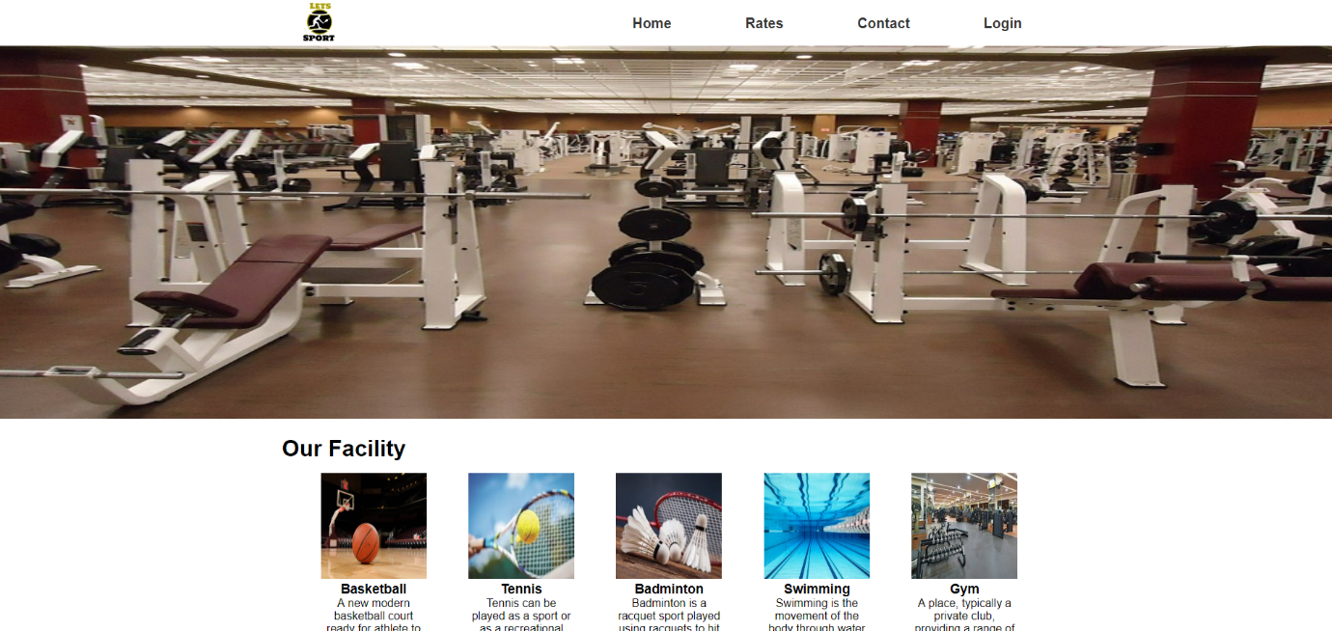

Figure : Home page

This homepage which is a default page consists of footer, header and sub-body sections. Public is unable to book the facilities.



Figure : Header

Move the mouse cursor over the “Home” on the header. The background of “Home” changes to grey instantly as shown in Figure 18. Click on this and you will be redirected into the page displayed in Figure 17.

Click on “Rates” on the header and it will scroll to the “Rates” section on the same page. Similarly, it will scroll to the footer when “Contact” is clicked.

* + 1. Login form

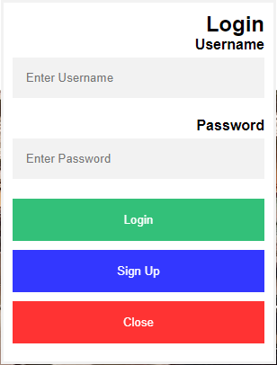

Figure : Login form

To log in or register, click on “Login” and the form will pop up as shown in Figure 19. There are 3 options on the following form; Login, Sign-up for online booking facilities and Close to exit the form.

* 1. Sign Up page

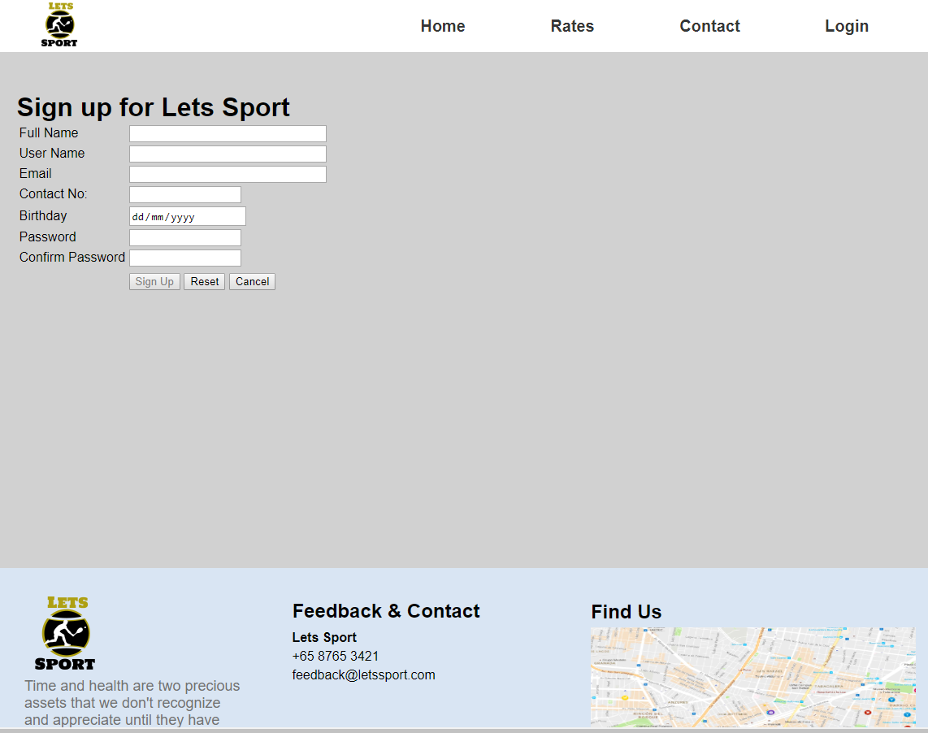

Figure : Sign Up

Select “Sign Up” in the Login form and you will be redirected to sign up page where you can fill the personal details.

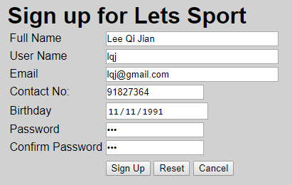

Figure : Sign Up completed

After filling all the details, click on “Sign Up” to register. It will bring you to “My Account” page. If you have made a few errors, you can click “Reset” to clear all the fields. “Cancel” button will redirect you to the homepage if you decide not to register.

* 1. Home page (After Login)

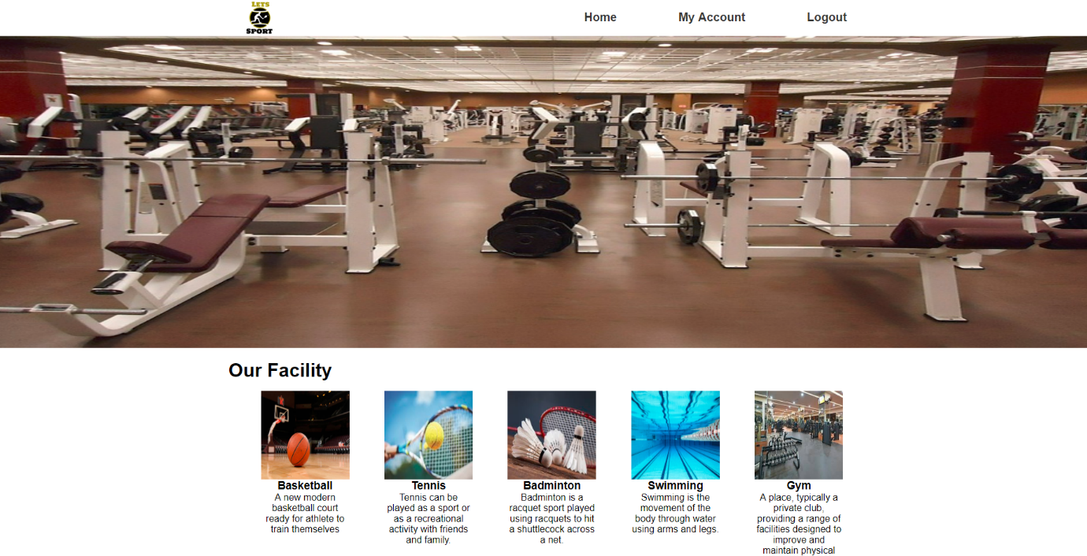

Figure : Homepage (After Login)

It is similar to the Figure 17 except the header show in Figure 23. Registered users are allowed to book facilities.



Figure : Header (After Login)

Click on “My Account” to view the user’s profile, booking details and booking facilities.

* 1. My Account page

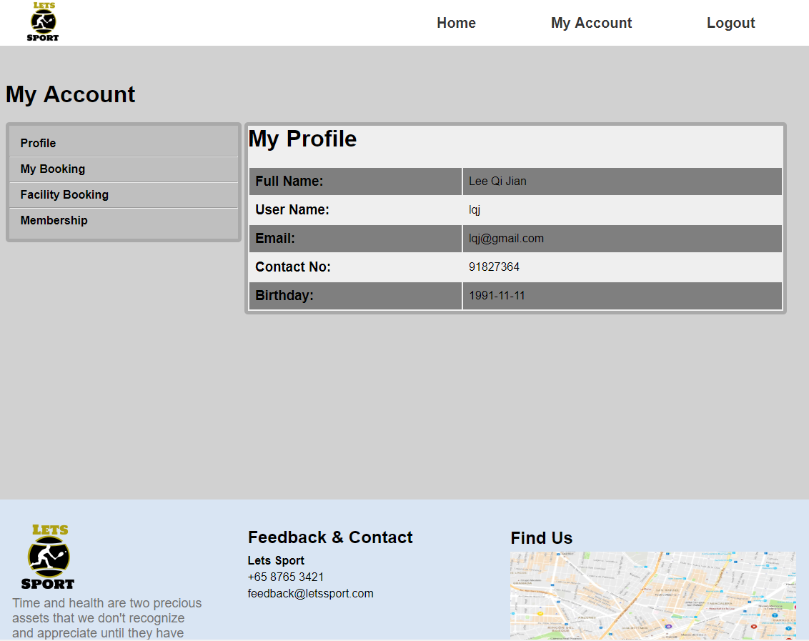

Figure : My Account

It consists of heading section, left navigation bar and footer section. “My Profile” is the default page for this page.

* 1. My Booking page (No results)

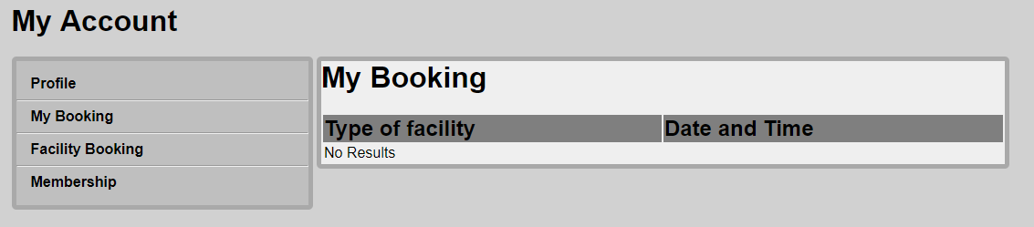

Figure : My Booking – No Results

Select “My Booking” to view the booking details consisting of type of facilities, date and time. “No results” is shown as the user have not made any booking yet.

* 1. Booking facility page

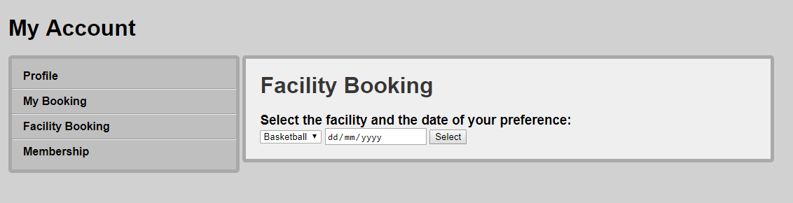

Figure : Booking facility

This page has 2 drop-list boxes which allows you to choose type of facility and date and one button to view the timeslots.

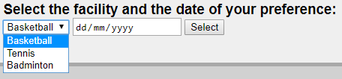

Figure : Booking facility type

Select Basketball.

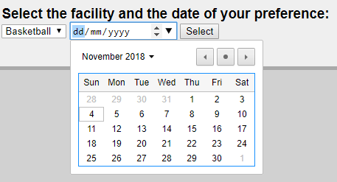

Figure : Booking facility date

Select 5 Nov 2018. Then click on “Select”

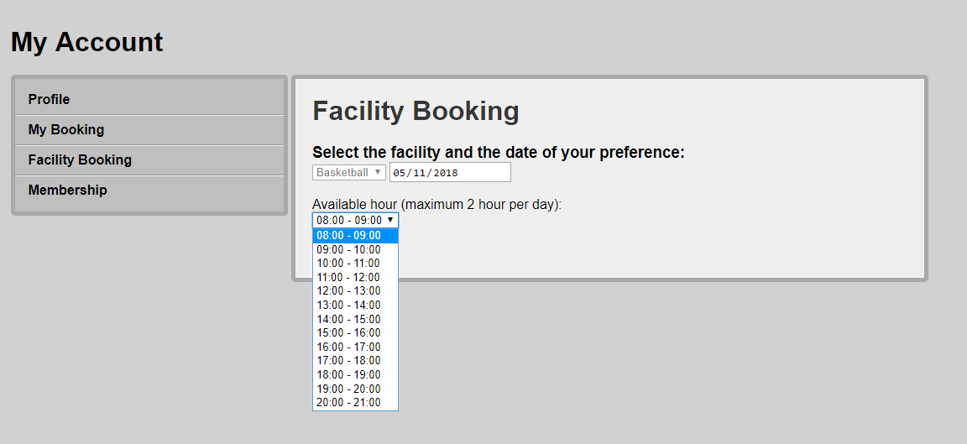

Figure : Booking facility timeslot 1

Figure 29 indicates that there are available timeslots in the drop-list box based on the “booking” table in database.

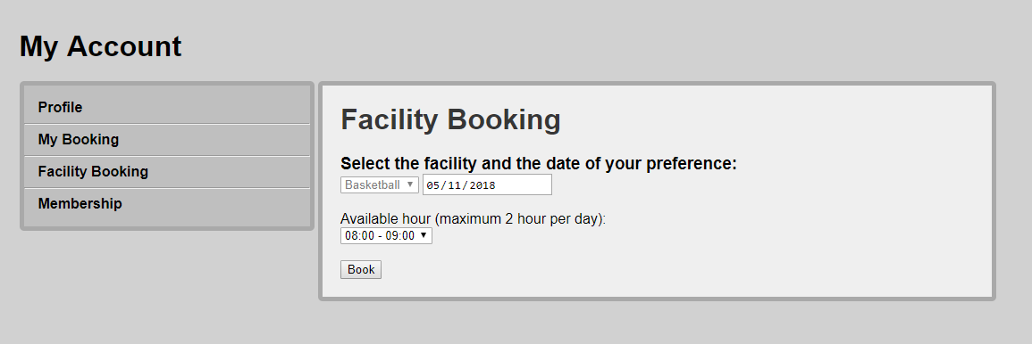

Figure : Booking facility testing

Select one timeslot and then click on “Book”. In this project testing, we book first timeslot from 8am to 9am.

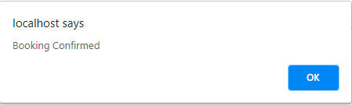

Figure : Booking confirmed

Upon the successful booking, the message box appears displayed in Figure 31. Click on OK to redirect to “My Account” page.

* + 1. Booking facility available timeslot

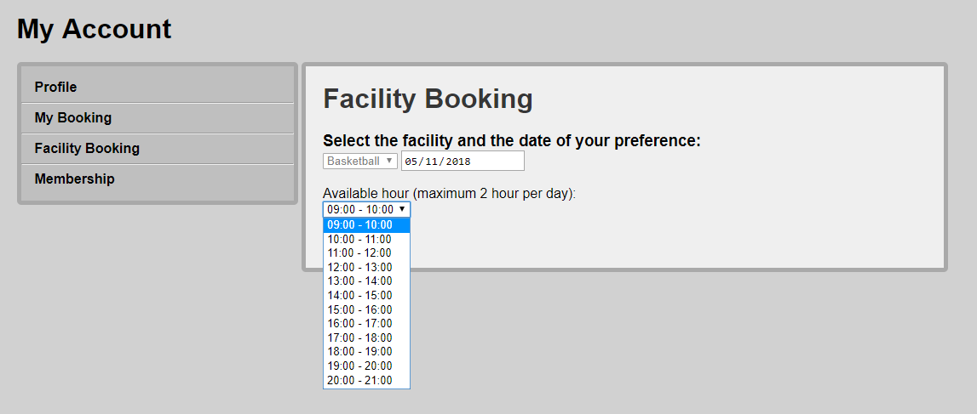

Figure : Booking facility timeslot 2

Assume we have booked the first timeslot shown in Figure 30, we will try to book another timeslot. You can see that there is no “8:00 – 9:00” in the drop-list box displayed in Figure 32. Book 9am-10am period and the booking will be successfully confirmed shown in Figure 31.

* + 1. Booking limit exceed

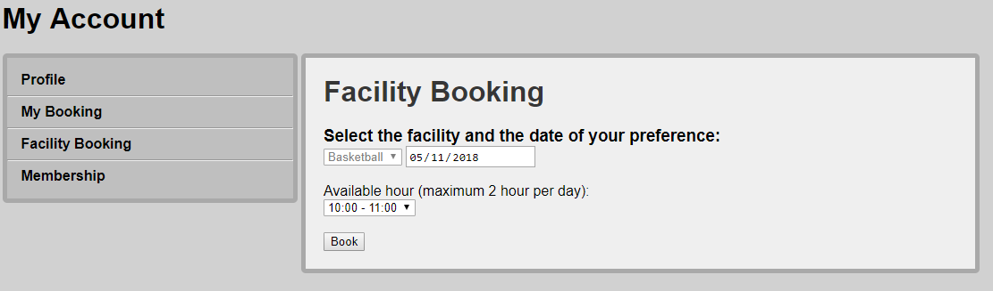

Figure : Booking Facility timeslot 3

Assume we have booked 2 timeslots for the same date from Figure 30 and Figure 32, we will try to book another timeslot.

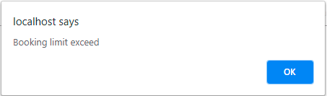

Figure : Booking limit exceed

The message box stating “Booking limit exceed” pops up like in Figure 34.

* 1. My Booking page (Records exist)

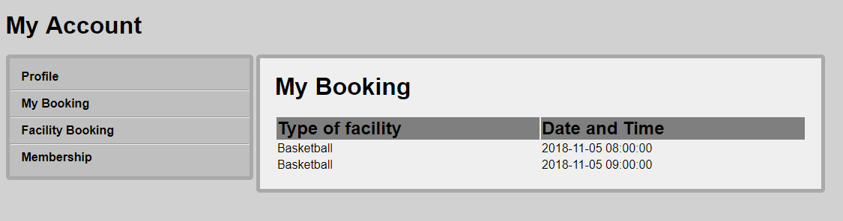

Figure : My Booking (Records exist)

Assume you have done the following tasks in Figure 30 and Figure 32, this page shows 2 rows of booking details.

* 1. Membership page

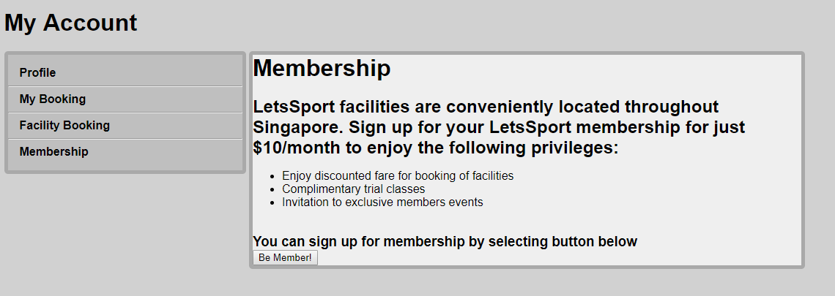

Figure : Membership for non-members

In Figure 36, this page is shown for non-members and encourage registered users to enjoy the privileges of membership. To do so, click on “Be Member!”. It will update the column “Member” in letssport table in database from 0 to 1.

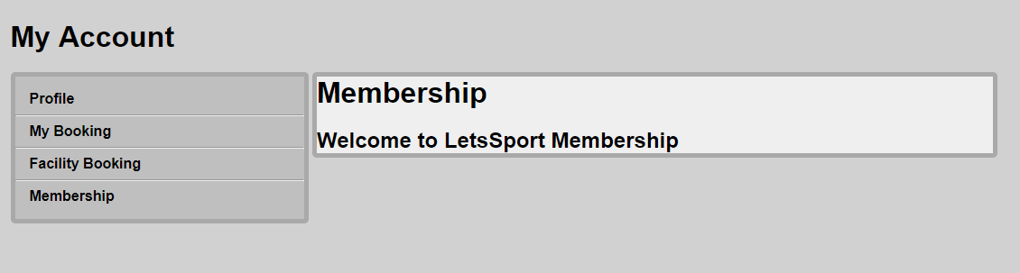

Figure : Membership

In Figure 37, the user now becomes a member of LetsSport.

1. Conclusion

In this project, we applied things that we learned from the lecture. We built a business functional website.

We implemented:

1. Session
2. Hashing for password (security related)
3. Transaction between the website with the server database
4. Basic HTML, CSS, Javascript
5. Validation for input boxes

**What has been deferred**:

1. This website did not implement the payment logic and system.
2. This website not hosted online yet, it is only in the local computer.
3. Appendices:
   1. Source Codes
      1. index.php

**<?php**  
    include "./php/common/header.php";  
    echo '  
        <!DOCTYPE html>  
        <html lang="en">  
        <head>  
            <title>Lets Sport</title>  
            <meta charset="utf-8">  
            <link rel="stylesheet" href="./styles/index.css">  
        </head>  
        <body>  
    ';  
    include "./php/common/hero.php";  
    echo '  
        <div id="container">  
            <div id="sub-menu">  
                <h1>Our Facility</h1>  
                <ul id="ul-sub-menu">  
                    <li>  
                        <div class="facility-div">  
                            <img src="assets/basketball.jpg" class="facility-image">  
                            <h3>Basketball</h3>  
                                                        <div class="facility-para">  
                                                                <p>A new modern basketball court ready for athlete to train themselves</p>  
                                                        </div>  
                        </div>  
                    </li>  
                    <li>  
                        <div class="facility-div">  
                            <img src="assets/tennis.jpg" class="facility-image">  
                            <h3>Tennis</h3>  
                                                        <div class="facility-para">  
                                                                <p>Tennis can be played as a sport or as a recreational activity with friends and family.</p>  
                                                        </div>  
                        </div>  
                    </li>  
                    <li>  
                        <div class="facility-div">  
                            <img src="assets/badminton.jpg" class="facility-image">  
                            <h3>Badminton</h3>  
                                                        <div class="facility-para">  
                                                                <p>Badminton is a racquet sport played using racquets to hit a shuttlecock across a net.</p>  
                                                        </div>  
                        </div>  
                    </li>  
                    <li>  
                        <div class="facility-div">  
                            <img src="assets/swimming.jpg" class="facility-image">  
                            <h3>Swimming</h3>  
                                                        <div class="facility-para">  
                                                                <p>Swimming is the movement of the body through water using arms and legs.</p>  
                                                        </div>  
                        </div>

 </li>  
                    <li>  
                        <div class="facility-div">  
                            <img src="assets/gym.jpg" class="facility-image">  
                            <h3>Gym</h3>  
                                                        <div class="facility-para">  
                                                                <p>A place, typically a private club, providing a range of facilities designed to improve and maintain physical fitness and health.</p>  
                                                        </div>  
                        </div>  
                    </li>  
                </ul>  
            </div>  
            <div id="container2">  
                <div id="div_rates">  
                    <div id="show_rates">  
                        <h1>Our Rates</h1>  
                        <table id="rates_table" border="1">  
                            <thead>  
                                <tr>  
                                    <th rowspan="2">Facility</th>  
                                    <th colspan="2">Price per hour</th>  
                                </tr>  
                                <tr>  
                                    <th>Member</th>  
                                    <th>Non-Member</th>  
                                </tr>  
                            </thead>  
                            <tbody>  
                                <tr>  
                                    <td>BasketBall</td>  
                                    <td>$100</td>  
                                    <td>$120</td>  
                                </tr>  
                                <tr>  
                                    <td>Tennis</td>  
                                    <td>$10</td>  
                                    <td>$12</td>  
                                </tr>  
                                <tr>  
                                    <td>Badminton</td>  
                                    <td>$7</td>  
                                    <td>$9</td>  
                                </tr>  
                                <tr>  
                                    <td>Swimming</td>  
                                    <td>$0.90</td>  
                                    <td>$1.40</td>  
                                </tr>  
                                <tr>  
                                    <td>Gym</td>  
                                    <td>$0.90</td>  
                                    <td>$1.40</td>  
                                </tr>  
                            </tbody>  
                        </table>  
                    </div>  
                </div>  
            </div>';  
    include "./php/common/footer.php";  
    echo '  
        </div>  
        </body>  
        </html>  
    '  
**?>**

* + 1. signup.php

**<?php**  
    include "./php/common/header.php";  
    echo '  
            <!DOCTYPE html>  
            <html lang="en">  
            <head>  
                    <title>Lets Sport</title>  
                    <meta charset="utf-8">  
                    <link rel="stylesheet" href="./styles/index.css">  
            </head>  
            <body>  
    ';  
    $html = '  
    <div id="signup-div">  
        <div id="signup-inside">  
            <h1>Sign up for Lets Sport</h1>  
          
            <form action="php/Add_New_User.php" method="post" id="signup_form">  
                <table border="0">  
                <tr>  
                    <td>Full Name</td>  
                    <td><input type="text" name="fullname" maxlength="30" size="30" required></td>  
                </tr>  
                <tr>  
                    <td>User Name</td>  
                    <td> <input type="text" name="username" maxlength="30" size="30" required></td>  
                </tr>  
                <tr>  
                    <td>Email</td>  
                    <td> <input type="text" name="email" maxlength="30" size="30" required></td>  
                </tr>  
                <tr>  
                    <td>Contact No:</td>  
                    <td><input type="text" name="hp" pattern="[0-9]{8}" size="15" required></td>  
                </tr>  
                <tr>  
                    <td>Birthday</td>  
                    <td><input type="date" name="birthday" required></td>  
                </tr>  
                    <td>Password</td>  
                    <td><input type="password" name="password" maxlength="15" size="15" required id="password1" onchange="testPassword()"></td>  
                </tr>  
                    <tr>  
                    <td>Confirm Password</td>  
                    <td><input type="password" name="password2" maxlength="15" size="15" required id="password2" onchange="testPassword()"></td>  
                </tr>  
                <tr>  
                    <td></td>  
                    <td id="password_error"><span style="color: red">*Password does not match</span></td>  
                </tr>  
                <tr>  
                    <td></td>  
                    <td><input type="submit" value="Sign Up" disabled id="submit_button">  
                    <input type="reset" name= "reset" value="Reset">  
                    <a href="index.php"><button type="button">Cancel</button></a></td>  
                </tr>  
                </table>  
            </form>  
        </div>  
    </div>

<script>  
        var password1 = document.getElementById("password1");  
        var password2 = document.getElementById("password2");  
        var submitButton = document.getElementById("submit_button");  
        var form = document.getElementById("signup_form");  
        var errorMessage = document.getElementById("password_error");  
  
        function testPassword() {  
            if (password1.value && password2.value) {  
                submitButton.disabled = false;  
            } else {  
                submitButton.disabled = true;  
            }  
        }  
  
        form.addEventListener("submit", function(e) {  
            e.preventDefault();  
            if (password1.value != password2.value) {  
                errorMessage.style.display = "inline-block";  
            } else {  
                form.submit();  
            }  
        });  
    </script>  
      
    </body>  
    </html>';  
  
    echo $html;  
    include "./php/common/footer.php";  
**?>**

* + 1. myAcount.php

**<?php**  
    [session_start](http://www.php.net/session_start)();  
    include "./php/dbconnect.php";  
    $user_id = $_SESSION["user_id"];  
    $sql = "SELECT * FROM letssport WHERE id='**$user_id**'";  
    $result = [mysqli_query](http://www.php.net/mysqli_query)($conn,$sql) or [die](http://www.php.net/die)("Error: ".[mysqli_error](http://www.php.net/mysqli_error)($conn));  
    $row=[mysqli_fetch_array](http://www.php.net/mysqli_fetch_array)($result);  
    echo '  
            <!DOCTYPE html>  
            <html lang="en">  
            <head>  
                    <title>Lets Sport</title>  
                    <meta charset="utf-8">  
                    <link rel="stylesheet" href="./styles/index.css">  
            </head>  
            <body>  
    ';  
    include "./php/common/header.php";  
    echo '  
    <div id="my-account-div">  
        <div id="my-account-inside">  
            <h1>My Account</h1>';  
  
    include "./php/myaccount/sidebar.php";  
  
    echo '  
            <div id="my-account-content">  
                <h1>My Profile</h1>  
                <div id="show-profile">  
                <table>  
                <tr>  
                    <td><h3>Full Name:<h3></td>  
                    <td>'.[sprintf](http://www.php.net/sprintf)('%s', $row["FullName"]).'</td>  
                </tr>  
                <tr>  
                    <td><h3>User Name:<h3></td>  
                    <td>'.[sprintf](http://www.php.net/sprintf)('%s', $row["UserName"]).'</td>  
                </tr>  
                <tr>  
                    <td><h3>Email:<h3></td>  
                    <td>'.[sprintf](http://www.php.net/sprintf)('%s', $row["Email"]).'</td>  
                </tr>  
                <tr>  
                    <td><h3>Contact No:<h3></td>  
                    <td>'.[sprintf](http://www.php.net/sprintf)('%s', $row["HP"]).'</td>  
                </tr>  
                <tr>  
                    <td><h3>Birthday:</td>  
                    <td>'.[sprintf](http://www.php.net/sprintf)('%s', $row["Birthday"]).'</td>  
                </tr>  
                </table>  
                </div>  
            </div>  
        </div>  
    </div>    
    </body>  
    </html>';  
    include "./php/common/footer.php";  
 **?>**

* + 1. mybooking.php

**<?php**  
    [session_start](http://www.php.net/session_start)();  
    include "./php/dbconnect.php";  
    $user_id = $_SESSION["user_id"];  
    $sql = "SELECT * FROM booking INNER JOIN facility ON facility.id = booking.facility_id WHERE user_id='**$user_id**'";  
    $result = [mysqli_query](http://www.php.net/mysqli_query)($conn,$sql) or [die](http://www.php.net/die)("Error: ".[mysqli_error](http://www.php.net/mysqli_error)($conn));  
    echo '  
            <!DOCTYPE html>  
            <html lang="en">  
            <head>  
                    <title>Lets Sport</title>  
                    <meta charset="utf-8">  
                    <link rel="stylesheet" href="./styles/index.css">  
            </head>  
            <body>  
    ';  
    include "./php/common/header.php";  
    echo '  
    <div id="my-account-div">  
        <div id="my-account-inside">  
            <h1>My Account</h1>';  
  
    include "./php/myaccount/sidebar.php";  
  
    echo '  
                <div id="my-account-content">  
                    <h1>My Booking</h1>  
                    <div id="show-booking">  
                    <table>  
                        <tr>  
                            <td><h2>Type of facility</h2></td>  
                            <td><h2>Date and Time<h2></td>  
                        </tr>';  
                        if ([mysqli_num_rows](http://www.php.net/mysqli_num_rows)($result) > 0) {  
              
                            while($row = [mysqli_fetch_array](http://www.php.net/mysqli_fetch_array)($result)) {  
                                echo "<tr><td>". $row["Type"]. "</td><td>". $row["datetime"]. "</td></tr>";  
                            }  
                        } else {  
                            echo "<tr><td colspan='2' text-align='center'>No Results</td></tr>";  
                        }  
                        echo '  
                    </table>  
                </div>  
            </div>  
        </div>  
    </div>    
    </body>  
    </html>';  
    include "./php/common/footer.php";  
 **?>**

* + 1. facilityBooking.php

**<?php**  
    include "./php/common/header.php";  
    echo '  
            <!DOCTYPE html>  
            <html lang="en">  
            <head>  
                    <title>Lets Sport</title>  
                    <meta charset="utf-8">  
                    <link rel="stylesheet" href="./styles/index.css">  
            </head>  
            <body>  
    ';  
    echo '  
    <div id="my-account-div">  
        <div id="my-account-inside">  
            <h1>My Account</h1>';  
  
    include "./php/myaccount/sidebar.php";  
  
    echo '  
                <div id="facility-booking-content">  
                <h1>Facility Booking</h1>  
                <h3>Select the facility and the date of your preference:</h3>  
                <form action="./timetable.php" method="POST" id="facility_form">  
                    <select name="facility">  
                        <option value="basketball">Basketball</option>  
                        <option value="tennis">Tennis</option>  
                        <option value="badminton">Badminton</option>  
                    </select>  
                    <input type="date" name="date" id="datetime">  
                    <input type="submit" value="Select">  
                </form>  
            </div>  
        </div>  
    </div>  
    <script>  
        var form = document.getElementById("facility_form");  
        var datetime = document.getElementById("datetime");  
  
        form.addEventListener("submit", function(e) {  
            e.preventDefault();  
            if (datetime.value) {  
                form.submit();  
            } else {  
                alert("Please choose a date");  
            }  
        });  
    </script>  
    </body>  
    </html>';  
    include "./php/common/footer.php";  
**?>**

* + 1. timetable.php

**<?php**  
    [session_start](http://www.php.net/session_start)();  
    include "php/dbconnect.php";  
  
    if (([isset](http://www.php.net/isset)($_POST['date'])) && ([isset](http://www.php.net/isset)($_POST['facility'])))  
    {  
        $date = $_POST['date'];  
        $facility = $_POST['facility'];  
        $timing = [array](http://www.php.net/array)();  
  
        $sql = 'SELECT DATE_FORMAT(datetime, "%H:%i") as timing, facility_id FROM `booking` INNER JOIN facility ON facility.id = booking.facility_id WHERE facility.Type = "' . $facility . '" AND datetime between \'' . $date . '\' and \'' . $date . ' 23:59:59\';';  
        $result = [mysqli_query](http://www.php.net/mysqli_query)($conn, $sql) or [die](http://www.php.net/die)("Error: ".[mysqli_error](http://www.php.net/mysqli_error)($conn));  
  
        if ($result->num_rows > 0) {  
                // output data of each row  
                while($row = $result->fetch_assoc()) {  
                    [array_push](http://www.php.net/array_push)($timing, $row["timing"]);  
                }  
        }  
    }  
  
    $sql2 = 'SELECT * FROM facility WHERE Type = "' . $facility . '"';  
    $result_facility = [mysqli_query](http://www.php.net/mysqli_query)($conn,$sql2) or [die](http://www.php.net/die)("Error: ".[mysqli_error](http://www.php.net/mysqli_error)($conn));  
    $row2 = [mysqli_fetch_array](http://www.php.net/mysqli_fetch_array)($result_facility,MYSQLI_ASSOC);  
  
    $facility_id = $row2['id'];  
  
    $available_period = [array](http://www.php.net/array)(  
        "08:00", "09:00", "10:00", "11:00", "12:00", "13:00", "14:00", "15:00", "16:00", "17:00", "18:00", "19:00", "20:00"  
    );  
    $available_period = [array_diff](http://www.php.net/array_diff)($available_period, $timing);  
    $available_period_html = "";  
  
    foreach ($available_period as &$value) {  
        $hour = [explode](http://www.php.net/explode)(":", $value)[0];  
        $next_hour = [strval](http://www.php.net/strval)($hour + 1);  
        if ([strlen](http://www.php.net/strlen)($next_hour) == 1) {  
            $next_hour = "0" . $next_hour;  
        }  
        $next_value = $next_hour . ":00";  
        $available_period_html .= '<option value="' . $value . '">' . "**$value** - **$next_value**" . '</option>';  
    }

    echo '  
            <!DOCTYPE html>  
            <html lang="en">  
            <head>  
                    <title>Lets Sport</title>  
                    <meta charset="utf-8">  
                    <link rel="stylesheet" href="./styles/index.css">  
            </head>  
            <body>  
    ';

include "./php/common/header.php";  
    echo '  
    <div id="my-account-div">  
        <div id="my-account-inside">  
            <h1>My Account</h1>';  
  
    include "./php/myaccount/sidebar.php";  
  
    echo '  
            <div id="facility-booking-content">  
                <h1>Facility Booking</h1>  
                <h3>Select the facility and the date of your preference:</h3>  
                <form action="./php/book_facility/book_facility.php" method="POST">  
                    <select name="facility" disabled>  
                        <option value="basketball" ' . ($facility == "basketball" ? "selected" : "") . '>Basketball</option>  
                        <option value="tennis" ' . ($facility == "tennis" ? "selected" : "") . '>Tennis</option>  
                        <option value="badminton" ' . ($facility == "badminton" ? "selected" : "") . '>Badminton</option>  
                    </select>  
                    <input type="hidden" name="facility" value=' . $facility_id . '>  
                    <input type="date" name="date" value="' . $date . '" readonly>  
                    <br>  
                    <br>  
                    Available hour (maximum 2 hour per day):  
                    <br>  
                    <select name="time">  
                        ' . $available_period_html . '  
                    </select>  
                    <br>  
                    <br>  
                    <input type="submit" value="Book" id="submit_form">  
                </form>  
            </div>  
        </div>  
    </div>  
    <script>  
        var form = document.getElementById("submit_form");  
        var hostname = window.location.hostname;  
        var pathnames = window.location.pathname.split("/");  
        var stringpath = hostname + "/";  
        for (var i = 1; i < pathnames.length - 1; i++) {  
            stringpath += pathnames[i] + "/";  
        }  
        console.log(stringpath);  
        form.addEventListener("submit", function(e) {  
            e.preventDefault();  
            if (confirm("Facility booking will be executed and you will directly pay from your credit card")) {  
                form.submit();  
            }  
        });  
    </script>  
    </body>  
    </html>';  
    include "./php/common/footer.php";  
**?>**

* + 1. membership.php

**<?php**  
    [session_start](http://www.php.net/session_start)();  
    include "./php/dbconnect.php";  
    $user_id = $_SESSION['user_id'];  
    $sql = "SELECT * FROM letssport WHERE id='**$user_id**'";  
    $result = [mysqli_query](http://www.php.net/mysqli_query)($conn,$sql) or [die](http://www.php.net/die)("Error: ".[mysqli_error](http://www.php.net/mysqli_error)($conn));  
    $row=[mysqli_fetch_array](http://www.php.net/mysqli_fetch_array)($result);  
    echo '  
            <!DOCTYPE html>  
            <html lang="en">  
            <head>  
                    <title>Lets Sport</title>  
                    <meta charset="utf-8">  
                    <link rel="stylesheet" href="./styles/index.css">  
            </head>  
            <body>  
    ';  
    include "./php/common/header.php";  
    echo '  
    <div id="my-account-div">  
        <div id="my-account-inside">  
            <h1>My Account</h1>';  
  
    include "./php/myaccount/sidebar.php";  
  
    echo '  
            <div id="my-account-content">  
                <h1>Membership</h1>  
        ';  
        if ($row['Member']==0){  
            echo '<h2>LetsSport facilities are conveniently located throughout Singapore. Sign up for your LetsSport membership for just $10/month to enjoy the following privileges:</h2>  
                <ul>  
                    <li>Enjoy discounted fare for booking of facilities</li>  
                    <li>Complimentary trial classes</li>  
                    <li>Invitation to exclusive members events</li>  
                </ul>  
                <br>  
                <h3>You can sign up for membership by selecting button below</h3>  
                <form action="php/myaccount/bemember.php" method="POST">  
                <input type="submit" name="member" value="Be Member!" >  
                </form>  
                ';  
        }  
        else{  
            echo '<h2>Welcome to LetsSport Membership</h2>';  
        }  
            echo '  
            </div>  
        </div>  
    </div>    
    </body>  
    </html>';  
    include "./php/common/footer.php";  
 **?>**

* + 1. login_user.php

**<?php** [ob_start](http://www.php.net/ob_start)(); **?>**  
**<?php**  
    [session_start](http://www.php.net/session_start)();  
    include "../dbconnect.php";  
     
    //if ((isset($_POST['password'])) && (isset($_POST['username'])))  
    //{  
    //  $username=$_POST['username'];  
    //  $password=$_POST['password'];  
  
    if (([isset](http://www.php.net/isset)($_POST['password'])) && ([isset](http://www.php.net/isset)($_POST['username'])))  
    {  
        $myusername = [mysqli_real_escape_string](http://www.php.net/mysqli_real_escape_string)($conn,$_POST['username']);  
        $mypassword = [md5](http://www.php.net/md5)([mysqli_real_escape_string](http://www.php.net/mysqli_real_escape_string)($conn,$_POST['password']));  
        
      $sql = "SELECT * FROM letssport WHERE UserName = '**$myusername**' and Password = '**$mypassword**'";  
  
        $result = [mysqli_query](http://www.php.net/mysqli_query)($conn,$sql) or [die](http://www.php.net/die)("Error: ".[mysqli_error](http://www.php.net/mysqli_error)($conn));  
        $row = [mysqli_fetch_array](http://www.php.net/mysqli_fetch_array)($result,MYSQLI_ASSOC);  
          
        $count = [mysqli_num_rows](http://www.php.net/mysqli_num_rows)($result);  
          
        // If result matched $myusername and $mypassword, table row must be 1 row  
      
        if($count == 1) {  
        if ($row['Member']==0)  
            $strMember="No";  
        else  
            $strMember="Yes";  
         //session_register("myusername");  
         $_SESSION['user_id'] = $row["id"];  
         $_SESSION['login_user'] = $myusername;  
         echo "Welcome " . $row["FullName"]. " - Membership: " . $strMember;  
         [header](http://www.php.net/header)("location: ../../index.php");  
      }  
        else  
        echo "  
        <script>  
          alert('Account is invalid, please check your username and password');  
          window.location.href = '../../index.php';  
        </script>  
      ";  
    }  
**?>**  
**<?php** [ob_flush](http://www.php.net/ob_flush)(); **?>**

* + 1. logout.php

**<?php**  
    [session_start](http://www.php.net/session_start)();  
    [unset](http://www.php.net/unset)($_SESSION["user_id"]);  
    [header](http://www.php.net/header)("location: ../../index.php");      
**?>**

* + 1. book_facility.php

**<?php**  
    include "../dbconnect.php";  
  [session_start](http://www.php.net/session_start)();  
    
  $user_id = $_SESSION["user_id"];  
  $facility_id = $_POST["facility"];  
  $date = $_POST["date"];  
  $time = $_POST["time"];  
  
  *# CHECK A USER ALREADY BOOK 2 HOURS;* $sql_check = "SELECT * FROM booking WHERE user_id = **$user_id** AND datetime between '**$date**' and '**$date** 23:59:59';";  
  echo $sql_check;  
  $check = [mysqli_query](http://www.php.net/mysqli_query)($conn,$sql_check) or [die](http://www.php.net/die)("Error: ".[mysqli_error](http://www.php.net/mysqli_error)($conn));  
  $count = [mysqli_num_rows](http://www.php.net/mysqli_num_rows)($check);  
  
  if ($count < 2) {  
    $sql = "INSERT INTO booking (datetime, user_id, facility_id) VALUES ('**$date** **$time**:00', **$user_id**, **$facility_id**)";  
    if ([mysqli_query](http://www.php.net/mysqli_query)($conn, $sql)) {  
      $to = 'f33ee@localhost';  
      $subject = 'booking facility Just Sport';  
      $message = 'Your booking is confirmed with the details below:  
      Date = ' . $date . ' ' . $time . '  
      ';  
      $headers = 'From: f33ee@localhost' . '\r\n' . 'Reply-To: f33ee@localhost' . '\r\n' . 'X-Mailer: PHP/' . [phpversion](http://www.php.net/phpversion)();  
      [mail](http://www.php.net/mail)($to, $subject, $message, $headers, '-ff33ee@localhost');  
      echo "  
        <script>  
          alert('Booking Confirmed');  
          window.location.href = '../../myAccount.php';  
        </script>  
      ";  
    } else {  
      echo "  
        <script>  
          alert('Booking Failed');  
          window.location.href = '../../facilityBooking.php';  
        </script>  
      ";  
    }  
  } else {  
    echo "  
      <script>  
        var hostname = window.location.hostname;  
        var pathnames = window.location.pathname.split('/');  
        var stringpath = hostname + '/';  
        for (var i = 1; i < pathnames.length - 1; i++) {  
          stringpath += pathnames[i] + '/';  
        }  
        alert('Booking limit exceed');  
        window.location.href = '../../facilityBooking.php';  
      </script>  
    ";  
  }  
**?>**

* + 1. header.php

**<?php** [ob_start](http://www.php.net/ob_start)(); **?>**  
**<?php**  
    [session_start](http://www.php.net/session_start)();  
    $user_id = $_SESSION['user_id'];  
    $login_logout = '';  
    if (!$user_id) {  
        $login_logout = '  
            <a href="index.php" class="nav_link">  
                <div class="navbar_menu">  
                    Home  
                </div>  
            </a>  
            <a href="#div_rates" class="nav_link">  
                <div class="navbar_menu">  
                    Rates  
                </div>  
            </a>  
            <a href="#footer_div" class="nav_link">  
                <div class="navbar_menu">  
                    Contact  
                </div>  
            </a>  
            <a href="javascript:openForm()" class="nav_link">  
                <div class="navbar_menu">  
                    Login  
                </div>  
            </a>  
        ';  
        $url = [explode](http://www.php.net/explode)("/", $_SERVER['REQUEST_URI'])[3];  
          
        if ($url != 'index.php' && $url != 'signup.php') {  
            echo "  
                    <script>  
                        window.location.href = './index.php';  
                    </script>  
                ";  
        }  
    } else {  
        $login_logout = '  
          
        <a href="index.php" class="nav_link">  
            <div class="navbar_menu">  
                Home  
            </div>  
        </a>  
        <a href="myAccount.php" class="nav_link">  
            <div class="navbar_menu">  
                My Account  
            </div>  
        </a>  
            <a href="./php/authentication/logout.php" class="nav_link">  
                <div class="navbar_menu">  
                    Logout  
                </div>  
            </a>  
        ';  
    }

    $html = '  
        <nav>  
            <div id="nav_container">  
                <div id="logo_div">  
                    <a href="index.php">  
                        <img src="./assets/LOGO.png" id="logo">  
                    </a>

                </div>  
                <div id="navbar">  
                ' . $login_logout . '  
                    <div class="form-popup" id="myForm">  
                        <form action="./php/authentication/login_user.php" method="post" class="form-container">  
                        <h1>Login</h1>  
  
                        <label for="username"><b>Username</b></label>  
                        <input type="text" placeholder="Enter Username" name="username" required>  
  
                        <label for="password"><b>Password</b></label>  
                        <input type="password" placeholder="Enter Password" name="password" required>  
  
                        <button type="submit" class="btn">Login</button>  
                        <button type="button" class="btn New" onclick="SignForm()">Sign Up</button>  
                        <button type="button" class="btn cancel" onclick="closeForm()">Close</button>  
                        </form>  
                    </div>  
                </div>  
            </div>  
        <script>  
            function openForm() {  
                document.getElementById("myForm").style.display = "block";  
            }  
  
            function closeForm() {  
                document.getElementById("myForm").style.display = "none";  
            }  
            function SignForm(){  
                document.location="signup.php";  
            }  
        </script>  
        </nav>  
  
    ';  
    echo $html;  
**?>**  
**<?php** [ob_flush](http://www.php.net/ob_flush)(); **?>**

* + 1. hero.php

**<?php**  
    $html = '  
        <img src="./assets/hero2.jpg" style="height: 529px; width: 100%">  
    ';  
    echo $html;  
**?>**

* + 1. footer.php

**<?php**  
    $html = '  
    <footer>  
        <div id="footer_div">  
            <div id="footer-first">  
                <img src="./assets/LOGO.png" id="footer-logo">  
                <p>Time and health are two precious assets that we don\'t recognize and appreciate until they have been depleted.</p>  
            </div>  
            <div id="footer-second">  
                <h2>Feedback & Contact</h2>  
                <p><b>Lets Sport</b></p>  
                <p>+65 8765 3421</p>  
                <p>feedback@letssport.com</p>  
                <br>  
                <br>  
                <br>  
                <br>  
            </div>  
            <div id="footer-third">  
                <h2>Find Us</h2>  
                <img src="https://media.wired.com/photos/59269cd37034dc5f91bec0f1/191:100/pass/GoogleMapTA.jpg">  
            </div>  
        </div>  
    </footer>  
    ';  
    echo $html;  
**?>**

* + 1. bemember.php

**<?php**  
    include "../dbconnect.php";  
  [session_start](http://www.php.net/session_start)();  
  $user_id=$_SESSION['user_id'];  
  $sql = "UPDATE letssport SET Member='1' WHERE id='**$user_id**'";  
  if ([mysqli_query](http://www.php.net/mysqli_query)($conn, $sql)) {  
    echo "Record updated successfully";  
    [header](http://www.php.net/header)("location: ../../membership.php");  
} else {  
    echo "Error updating record: " . [mysqli_error](http://www.php.net/mysqli_error)($conn);  
}  
**?>**

* + 1. sidebar.php

**<?php**  
    $html = '  
    <div id="sidebar">  
        <ul id="ul-sidebar">  
            <li>  
                <a href="./myAccount.php" id="my-account"><b>Profile</b></a>  
            </li>  
            <hr>  
            <li>  
                <a href="./mybooking.php" id="mybooking"><b>My Booking</b></a>  
            </li>  
            <hr>  
            <li>  
                <a href="./facilityBooking.php" id="facility-booking"><b>Facility Booking</b></a>  
            </li>  
            <hr>  
            <li>  
                <a href="./membership.php"><b>Membership</b></a>  
            </li>  
        </ul>  
    </div>  
    <script>  
        const pathname = window.location.pathname;  
        const currentTab = pathname.split("/")[3];  
        switch(currentTab) {  
            case "myAccount.php":  
                document.getElementById("my-account").classList.add("selected");  
                break;  
            case "facilityBooking.php":  
                document.getElementById("facility-booking").classList.add("selected");  
                break;  
            case "timetable.php":  
                document.getElementById("facility-booking").classList.add("selected");  
                break;  
            case "mybooking.php":  
                document.getElementById("mybooking").classList.add("selected");  
                break;  
        }  
    </script>';  
    echo $html;  
**?>**

* + 1. Add_New_User.php

**<?php**  
    [session_start](http://www.php.net/session_start)();  
    include "dbconnect.php";  
  
    $fullname=$_POST['fullname'];  
    $username=$_POST['username'];  
    $email=$_POST['email'];  
    $hp=(int)$_POST['hp'];  
    $birthday=$_POST['birthday'];  
    $password=[md5](http://www.php.net/md5)($_POST['password']);  
  
    $sql = "INSERT INTO letssport (FullName, UserName, Email, HP, Birthday, Password, Member) VALUES('**$fullname**', '**$username**', '**$email**','**$hp**', '**$birthday**' ,'**$password**','0')";  
  
    if ([mysqli_query](http://www.php.net/mysqli_query)($conn, $sql)) {  
        $_SESSION['user_id'] = $conn->insert_id;  
        echo "  
            <script>  
                alert('User Created');  
                window.location.href = '../myAccount.php';  
            </script>  
        ";  
    } else {  
        $error_strings = [mysqli_error](http://www.php.net/mysqli_error)($conn);  
        echo '  
            <script>  
                alert("ERROR: ' . $error_strings . '");  
                window.history.back();  
            </script>  
        ';  
    }  
  
    [mysqli_close](http://www.php.net/mysqli_close)($conn);  
**?>**

* + 1. dbconnect.php

**<?php**  
$conn = **new** mysqli('localhost','f33ee','f33ee','f33ee');  
// @ to ignore error message display //  
if ($conn->connect_error){  
    echo "Database is not online";   
    [exit](http://www.php.net/exit);  
    // above 2 statments same as die() //  
    }  
/*  else  
    echo "Congratulations...  MySql is working..";  
*/  
if (!$conn->select_db ("f33ee"))  
    [exit](http://www.php.net/exit)("<p>Unable to locate the f33ee database</p>");  
**?>**

1. index.css

body {  
    **margin**: 0;  
    **padding**: 0;  
}  
body {**font-family**: Arial, Helvetica, sans-serif;}  
* {**box-sizing**: border-box;}  
  
/* Button used to open the contact form - fixed at the bottom of the page */  
.open-button {  
    **background-color**: #555;  
    **color**: white;  
    **padding**: 16px 20px;  
    **border**: none;  
    **cursor**: pointer;  
    **opacity**: 0.8;  
    **position**: fixed;  
    **right**: 28px;  
    **width**: 280px;  
}  
    
/* The popup form - hidden by default */  
.form-popup {  
**display**: none;  
**position**: fixed;  
**top**: 0;  
**right**: 15px;  
**border**: 3px solid #f1f1f1;  
**z-index**: 9;  
}  
  
/* Add styles to the form container */  
.form-container {  
**max-width**: 300px;  
**padding**: 10px;  
**background-color**: white;  
}  
  
/* Full-width input fields */  
.form-container input[type=text], .form-container input[type=password] {  
**width**: 100%;  
**padding**: 15px;  
**margin**: 5px 0 22px 0;  
**border**: none;  
**background**: #f1f1f1;  
}  
  
/* When the inputs get focus, do something */  
.form-container input[type=text]:focus, .form-container input[type=password]:focus {  
**background-color**: #ddd;  
**outline**: none;  
}  
  
/* Set a style for the submit/login button */  
.form-container .btn {  
**background-color**: #4CAF50;  
**color**: white;  
**padding**: 16px 20px;  
**border**: none;  
**cursor**: pointer;  
**width**: 100%;  
**margin-bottom**:10px;  
**opacity**: 0.8;  
}  
.form-container .New {  
    **background-color**: blue;  
}  
/* Add a red background color to the cancel button */  
.form-container .cancel {  
**background-color**: red;  
}

/* Add some hover effects to buttons */  
.form-container .btn:hover, .open-button:hover {  
**opacity**: 1;  
}  
  
h1, h2, h3, p {  
    **margin**: 0;  
    **padding**: 0;  
}  
  
nav a.inuse {  
    **font-size**: 200px;  
}  
  
footer {  
    **background-color**: #dce4f2;  
    **width**: 100vw;  
    **margin-left**: calc(-50vw + 50%);  
}  
  
.navbar_menu {  
    **display**: inline-block;  
    **padding**: 20px 50px;  
    **font-weight**: 600;  
    **font-size**: 20px;  
    **color**: #333;  
}  
  
.navbar_menu:hover {  
    **background-color**: #ddd;  
    **cursor**: pointer;  
    **color**: #888;  
}  
  
.navbar_menu_selected {  
    **background-color**: #aaa;  
}  
  
.nav_link {  
    **text-decoration**: none;  
}  
  
.facility-div {  
    **display**: inline-block;  
    **height**: 350px;  
    **width**: 150px;  
    **text-align**: center;  
}  
.facility-image {  
    **height**:150px;  
    **width**:150px;  
    **max-height**:100%;  
    **max-width**:100%;  
}  
.facility-para {  
    **height**: 150px;  
    **width**: 150px;  
    **position**: absolute;  
}  
.facility-div h2 {  
    **display**: inline-block;  
}  
  
.facility_content {  
    **display**: inline-block;  
}

#container {  
    **height**: auto;  
}  
  
#navbar {  
    **display**: inline-block;  
    **text-align**: right;  
    **vertical-align**: middle;  
    **width**: 85.5%;  
}  
  
#logo_div {  
    **display**: inline-block;  
    **margin**: 0 2%;  
    **vertical-align**: middle;  
    **width**: 10%;  
}  
  
#logo {  
    **width**: 60px;  
}  
  
#sub-menu {  
    **width**: 100%;  
    **padding**: 20px 0px 0px 0px;  
}  
  
#ul-sub-menu {  
    **list-style-type**: none;  
    **padding**: 0;  
}  
  
#ul-sub-menu li {  
    **display**: inline-block;  
    **margin-right**: 5%;  
}  
  
#ul-sub-menu li:first-child {  
    **margin**: 0px 5%;  
}  
  
#container2 {  
    **background**: url("../assets/marathon.jpg");  
    **width**: 100vw;  
    **margin-left**: calc(-50vw + 50%);  
    /* position: relative; */  
}  
  
#div_rates {  
    **background-color**: rgba(50, 50, 50, 0.9);  
    **width**: 100%;  
    **padding-bottom**: 50px;  
}  
  
#show_rates {  
    **width**: 1100px;  
    **margin**: 0 auto;  
    **color**: #ffffff;  
    **padding**: 30px 0px;  
}  
  
#show_rates h1 {  
    **width**: 1100px;  
    **margin**: 0 auto;  
    **color**: #ffffff;  
    **padding**: 10px 0px;  
}

#show_rates table {  
    **text-align**: center;  
    /* width:1095px; */  
    **width**: 100%;  
}  
  
#show_rates table th {  
    **font-size**: 25px;  
    **border-radius**: 5px;  
    **background-color**: #eeeeee;  
    **color**: #fa4251;  
}  
  
#show_rates table td {  
    **font-size**: 20px;  
    **border-radius**: 5px;  
}  
  
#show_rates table tbody {  
    **color**: #eeeeee;  
}  
  
#footer_div {  
    **width**: 1100px;  
    **margin**: 0 auto;  
    **color**: #ffffff;  
    **padding**: 30px 0px;  
}  
  
#footer_div h1 {  
    **margin**: 0 auto;  
    **color**: #000;  
    **padding**: 10px 0px;  
    **margin-bottom**: 20px;  
}  
  
#footer-first {  
    **width**: 25%;  
    **display**: inline-block;  
    **color**: #737373;  
    **font-size**: 18px;  
}  
  
#footer-second {  
    **margin-left**: 50px;  
    **width**: 33%;  
    **display**: inline-block;  
}  
  
#footer-second h2 {  
    **color**: #000;  
    **margin-bottom**: 10px;  
}  
#footer-second p {  
    **color**: #000;  
    **margin-bottom**: 5px;  
}  
  
#footer-logo {  
    **width**: 100px;  
}

#footer-third {  
    **display**: inline-block;  
}

#footer-third h2 {  
    **color**: #000;  
    **margin-bottom**: 5px;  
}  
  
#footer-third img {  
    **height**: 140.984px;  
    **width**: 400px;  
}  
  
#signup-div {  
    **height**: 67vh;  
    **background-color**: #d1d1d1;  
}  
  
#signup-inside {   
    **width**: 1100px;  
    **margin**: 0 auto;  
    **padding-top**: 50px;  
}  
  
#password_error {  
    **display**: none;  
}  
  
#my-account-div {  
    **min-height**: 67vh;  
    **padding-bottom**: 30px;  
    **background-color**: #d1d1d1;  
}  
  
#my-account-inside {   
    **width**: 1100px;  
    **margin**: 0 auto;  
    **padding-top**: 50px;  
}  
  
#my-account-inside h1 {  
    **margin-bottom**: 20px;  
}  
  
#sidebar {  
    **display**: inline-block;  
    **width**: 30%;  
    **background-color**: #c0c0c0;  
    **border**: 5px solid #aaaaaa;  
    **border-radius**: 5px;  
}  
  
#ul-sidebar {  
    **list-style-type**: none;  
    **padding**: 0;  
}  
  
#ul-sidebar a {  
    **text-decoration**: none;  
    **color**: black;  
}  
  
#ul-sidebar a:visited {  
    **text-decoration**: none;  
    **color**: black;  
}  
  
#ul-sidebar li {  
    **margin**: 0px 5%;  
    **color**: #000;  
}

#ul-sidebar li a.selected {  
    **margin**: 0;  
    **color**: red;  
}  
  
#my-account-content {  
    **display**: inline-block;  
    **width**: 69%;  
    **vertical-align**: top;  
    **background-color**: #eeeeee;  
    **border**: 5px solid #aaaaaa;  
    **border-radius**: 5px;  
    **padding**: 20px 20px;  
}  
  
#show-profile table {  
    **border**: 0;  
    **width**: 100%;  
    **text-align**: left;  
}  
  
#show-profile table tr:nth-child(odd){  
    **background-color**: grey;  
}  
#show-profile table td{  
    **padding**: 8px;  
}  
#show-profile table td:first-child{  
    **width**: 40%;  
}  
#show-booking table {  
    **border**: 0;  
    **width**: 100%;  
    **text-align**: left;  
}  
#show-booking table td:first-child {  
    **width**: 50%;  
}  
#show-booking table tr:first-child{  
    **background-color**:grey;  
}  
#facility-booking-content {  
    **display**: inline-block;  
    **width**: 69%;  
    **vertical-align**: top;  
    **background-color**: #eeeeee;  
    **border**: 5px solid #aaaaaa;  
    **border-radius**: 5px;  
    **padding**: 20px 20px;  
}  
  
#facility-booking-content h1 {  
    **color**: #333333;  
}  
  
**@media** only screen and (**min-width**: 1100px) {  
    #container {  
        **width**: 1100px;  
        **margin**: 0 auto;  
    }  
  
    #show_rates {  
        **width**: 1100px;  
        **margin**: 0 auto;  
        **color**: #ffffff;  
    }  
  
    #nav_container {  
        **width**: 1100px;  
        **margin**: 0 auto;  
    }  
}